LeeWayne Barrineau

10/2/19

The following is the Wild Wood Apartments database before any normalizations. 

1. There are no violations of first normal form that I could find. The above diagram is currently in violation of second and third normal form
2. The diagram below is the Wild Wood Apartments database fully normalized.

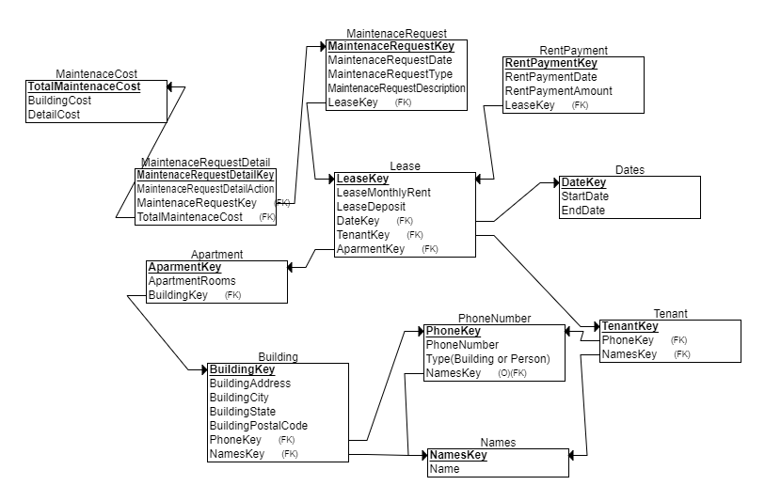

1. Start and end date inside the lease are a violation of Second normal form and thus needs to be its own entity. This is because the start and end date do not pertain towards the lease theme but rather towards information regarding a range of dates. These two attributes are currently in the lease entity, but these attributes can also be a maintenance completion entity. Remove the name attributes from the building entity and first and last name entity since these pertain a naming theme but not the tenant and the building. While yes, the name attribute can pertain to a building and tenant it can also pertain to different things. Since it would be easier to call another table to update items, then going through the different entity that names’ needs to be updated.SO, create a new entity called name with the attributes name and name key. Using this same logic of removing attributes in entities that revolve around another theme beside the current entity or entities it is in also remove the phone attribute from the tenant and building. Take this removed attribute and make it its own entity that is connected to the building and tenant. The phone attributes should be removed because it in its self in information about a number but not information about the current entities it is in. This is because information about a phone number does need nor depends on any information regarding anything else to determine what it is. Create a new entity from the maintenance request detail cost and the maintenance request building cost. These attributes should be separate from the entity, because most cost amount deprive there meaning of what is being cost from what the subject is. But in these cases, there are two money amount whose use the maintenance request detail for their subject. While these is not a problem per say, it would be more beneficial to just have a single attribute to show the cost of the request. There for the total of the two attributes should only be shown in the request detail while another entity can be used as a look up for the cost details instead of showing both inside the request detail entity. So, a new entity will be created to hold the building cost attribute and the detail cost attribute, with the primary key of the new entity linking back to the maintenance request details
2. While there a few new entities for the wild wood apartment database being fully normalized. The database still meets the business rules and needs of the Wild Wood Apartments.